Get Free Online Training From Westlaw

1. Use your Westlaw OnePass Password
2. Go to the West eLearning Center (http://www.westelearning.com) | 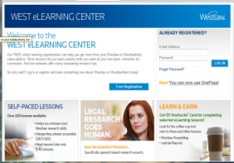
3. Click on the "Use OnePass" link | 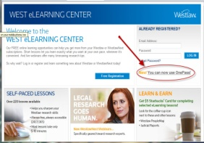
4. Sign in using your OnePass Password | 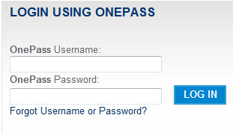
5. Locate the list of Self-Paced lesson subjects | 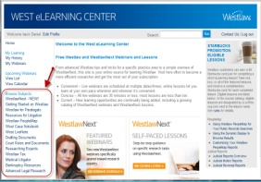
6. Students should consider taking the following Lessons:  - Getting Started on Westlaw  - Westlaw for Paralegals  - Resources for Litigation  - Drafting Documents  - Court Rules and Documents  - Advanced Legal Research | 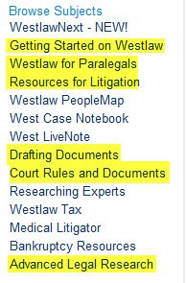
7. Students are to complete all lessons within each tab. | 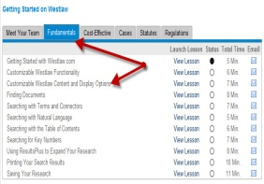
8. View any other lessons you desire.

Get Free Online Training from Lexis
Just go to: http://law.lexisnexis.com/communityportal/articles/articles.aspx?g=QfsTyLJ1USs=&c=fx3isG+H4A8=&a=dErKQyQPeww=
Or, if that’s too long, Google: free lexis paralegal training
