H O W T O U S E L E X I S

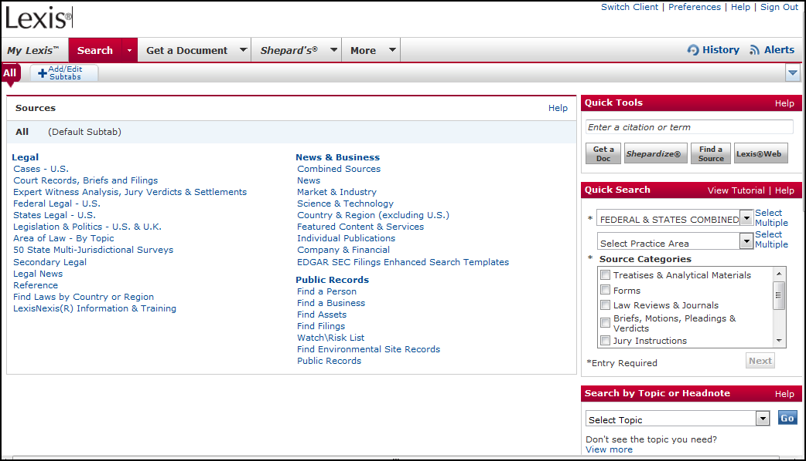

Following are some basic instruction on using Lexis online legal research. Note, however, that the best way to get to know Lexis is to get online and just use it!

PREFERENCES

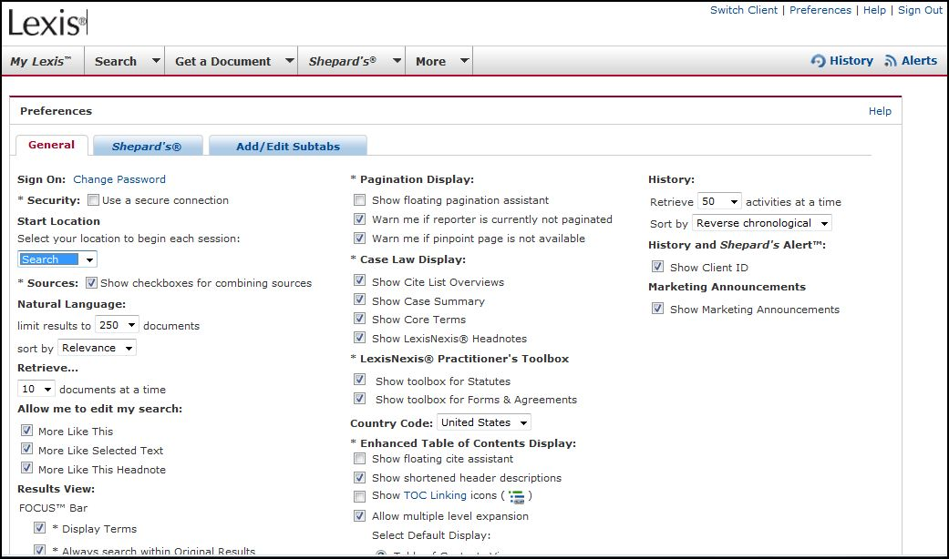

You can pick and choose how you want Lexis to display or search options and search results. Here are a few suggestions.

Start Location
You can choose where Lexis starts each time you sign on. The Search page is probably the most useful.

Show check boxes for combining resources
Lexis allows you to search multiple databases by providing check boxes. Any boxes selected will be included in the search.

Natural Language
You can change the number of results that are returned for a search. You can also change the way the results are ordered. If you want them to appear by date, the most recent first, select to sort by “Date” instead of “Relevance.”

Retrieve
This will tell Lexis how many cases or other authorities to show per page. It is set at first to 10 at a time, so if you get 50 results, there will be 5 pages with 10 results each.

Allow me to edit my search
When Lexis returns your search results, it can provide you with options for editing your search. For instance, if you find a particularly good headnote, you can ask Lexis to conduct a new search for more cases like that headnote. It is suggested that you keep all these checked.

Results view
This is some fine tuning, allowing the researcher to eliminate some of the Lexis options in when your results are shown. We suggest you leave this alone until you become familiar enough with Lexis to make personal preference choices.

Pagination Display
This option provides information as to the page by page setup of the document being viewed.

Case Law Display
When you are viewing a case, Lexis can show you several optional elements. You can de-select any of these that you want, but you probably want to leave them all selected.

Practitioner’s Toolbox
Lexis has a tool called the Practitioner’s Toolbox that provides information and research assistance. Leave it selected.

Country Code
Leave this selected as United States unless you are a Canadian student.

Enhanced Table of Contents Display
These are advanced options that provide tools while you are viewing an authority. Select the “Show floating cite assistant,” as this can be a useful tool. You can de-select it later if you like.

History
Sets options for the history of a case. You can change the amount of retrievals at a time if you like, but leave the order in Reverse Chronological mode.

Now all you have to do is click on SET.

LAYOUT OF LEXIS

The key to using Lexis is the TABS on the top left of the page. They look like this:



The Tabs
Notice that the new layout for Lexis has just a few tabs with drop-down options. To see more options, just click on the down arrow within the tab.

My Lexis Tab
A pre-set home page.

Search Tab
Choose a database and enter a search query to find relevant authority.

Get a Document Tab
Find a case, statute, or other document with just a title or citation.
Shepard’s Tab
Determine whether authority is still valid.
More Tab
This is mostly Lexis trying to sell more services.

MY LEXIS TAB

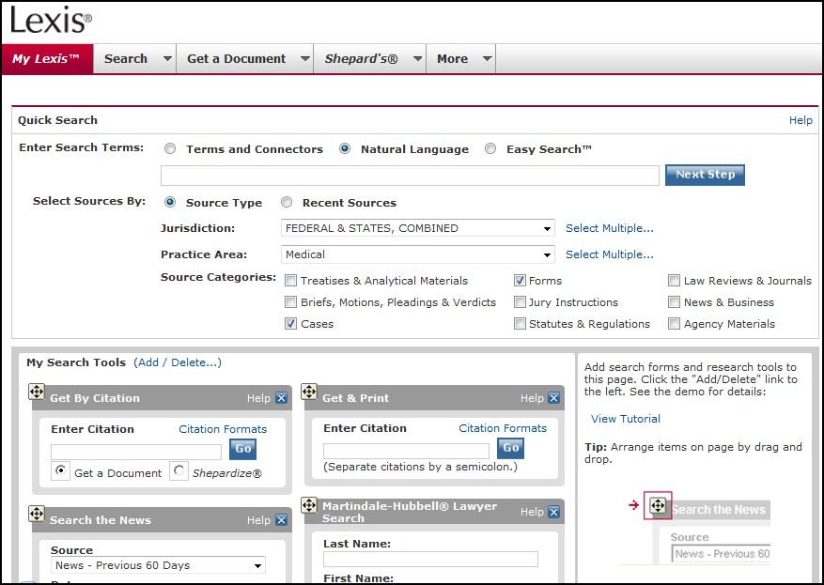

This is a home page that provides up-to-the-minute legal news and resources. It also provides shortcuts to commonly used search tools. Very customizable.

SEARCH TAB

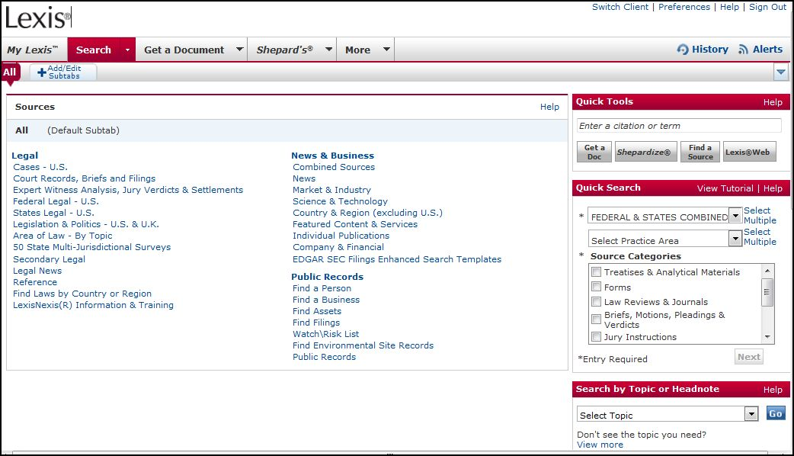

Allows you to choose a database in which to search, then allows you to enter a set of terms and phrases, called a query. Lexis will then retrieve authority relevant to your query from the selected database. Think of all the links as databases.

Sources
Shortcuts to many of the most popular research sources

Recently Used Sources
Very useful tool. Provides direct access to your most recently used databases.

Quick Tools
Helpful shortcut. Tip in a citation and click “Get a Doc” or “Shepardize” depending on what you are trying to do. Or enter a topic and click on “Find a Source.”

Quick Search
Another tool to focus your research within a group of databases that match your criteria.

Search by Topic or Headnote
Not as useful. Very broad topics.

Litigation and Transactional Resources
Again, not as useful. More of an effort to get subscribers to buy more services.

Subtabs
A great feature. This allows you to customize your own tabs (actually, subtabs) with quick links to practice areas and, most importantly, jurisdiction. You can add up to 18, but more is not always better.

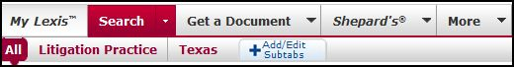

Now that you know the layout, let’s try searching.

Searching by Topic
If you have a topic to research, the best way to search is to click on the SEARCH tab.

Follow these instructions.

1. Click on the Search tab.

2. Select a database. You can choose what specific courts in which to research, or choose the topic of law to research. It is usually most effective to choose a court database, such as “State Court Cases, Combined.”

3. After choosing a database, Lexis will ask you to enter a search query. A query is a collection of words and phrases relevant to your research issue. There are two ways to enter your query: by Terms and Connectors or using Natural Language.

Terms and Connectors
This allows the researcher to list the terms and phrases, placing connectors between them. The connectors determine the relationship between the words. For instance, if you want the term suicide to appear within 50 words of the term physician, and for the term physician to appear within the same sentence as the term assisted, it would appear like this:

suicide w/50 physician w/s assisted

Lexis provides a box on the right hand side of the page that defines the possible connectors you can use. You can even click on one of the connectors and Lexis will place it in your query for you!

Natural Language
You can also research using natural language. In this case, simply provide your search terms separated by commas. Note that if you have any multi-word phrases, you should place them in quotation marks. This way Lexis will only search for the terms together, not individually.

For example:

suicide, homicide, ”physician assisted”

Lexis will also provide suggestions for expanding your terms. Just click on the “Suggest Terms for My Search” link on the right side of the Search Terms text box.

4. When you click on the Search button, Lexis will try to find cases relevant to your query.

5. The results page will list summaries of the cases that were found are listed. After the title of the case, Lexis will provide the following:

Case Title and Citation
Overview General description of the case
Core Terms: The most relevant terms from that case
Highlighted Terms: Terms from your query are highlighted within the case.
Shepard’s References: To the left of the title of the case a symbol will appear. The symbols indicate whether that case is still valid, or whether it has been treated positively or negatively by other cases.

The symbols look like this:

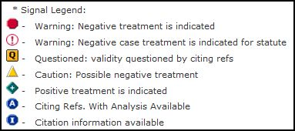

These symbols help you determine whether even looking at a case in the results page is worthwhile. For instance, if a case has a red stop sign shaped symbol (which is a negative treatment), you may want to skip it in favor of other, more positively treated cases.

6. Click on a title to a case. Lexis now provides the entire opinion, along with tools such as” Procedural Posture: How the case was affected procedurally.

Case History: Prior or subsequent opinions of the same legal matter
Case Summary: General description of the case
Core Terms: The most relevant terms from that case
Lexis Headnotes: You can use these or hide them.
The Opinion: The actual full court opinion.
Highlighted Terms: Terms from your query are highlighted within the case.
Shepard’s References: To the left of the title of the case a symbol will appear. The symbols indicate whether that case is still valid, or whether it has been treated positively or negatively by other cases.

7. If the case looks relevant, you can print it, download it, or even choose to view it in an easier to read format. Simply look for the following toolbar towards the top right of the page:

GET A DOCUMENT TAB
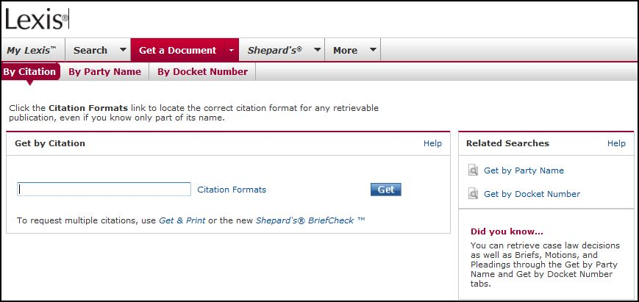
If you have a citation, a name of a party, or even a docket number you can quickly find the document using this tab. Notice that the subtabs help you target your search based on what information you have. You will use the Search Tab when you have a topic or issue that needs to be researched, and the Get a Document Tab when you have information and need to locate a specific case, act, or other document. This works with statutes, regulations, and any other type of citation.
You can practice by clicking on the Party Name subtab and typing in the name of a case, such as Roe v. Wade, or Plessy v. Ferguson. Or search for the citation 410 U.S. 113.

SHEPARD’S TAB

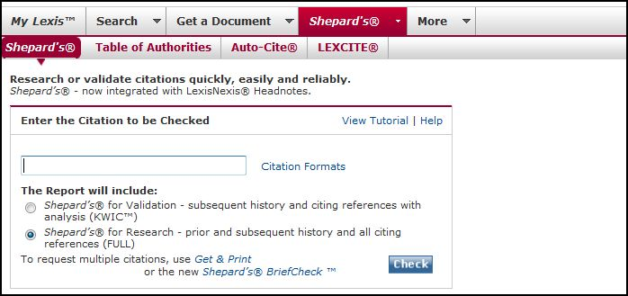

Shepard’s is a way to validate authority. It is a critical step in the research process. Once you have located a case, statute, or other form of primary authority, how can you be sure that the authority is still valid? The answer: Shepard’s.

Using the Shepard’s Tab Main Form
Simply enter the citation in the text field and Shepard’s will provide the histories and treatments of the case. As we will discuss below, you will use the symbols to determine if the case you have Shepardized is still valid.

Shepardizing a Search Result or While Reviewing a Document
If you are looking at a document, or if you have a citation you want to Shepardize, click on the Shepard’s tab. You will most likely only use the Shepard’s subtab under the main tab, as shown above. If you were looking at a document, Lexis automatically fills in the citation for you. If not, just type in the citation you want to Shepardize. Then click the Check button.

The Shepard’s results page provides the following:

Shepard’s Summary: Informs the researcher at-a-glance as to the kind of treatments and histories found in the results. The researcher should be especially concerned about any Warning Analysis. While Cautionary Analysis should be paid attention to, those treatments do not necessarily invalidate the case being Shepardized.

Prior History: These are the same case at a different level of litigation. There may be History symbols that affect the validity of the case you are Shepardizing. The key can be found at the bottom of each Shepard’s results page.

Citing Decisions: These are cases that have cited the case being Shepardized. There may be Treatments (symbols) provided that help determine the validity of the case being Shepardized. The key to these symbols are always found at the bottom of the page. The key looks like this:

More… Secondary Authority Online
While the majority of research online is for the purpose of locating primary authority, more and more secondary sources have become available on both Lexis and Westlaw, Lexis' main competitor. To find secondary sources, start on the SEARCH tab. On the right side of the page you will see a choice for Secondary Legal. You can choose on the sources listed below, or click on “View more sources.” Simply navigate through the choices provided. Lexis will then allow you to enter a search query for the source you chose. By going back to the Search tab, you could also choose to research by Area of Law-By Topic. If you click on one of the listed links, Lexis will provide both primary and secondary sources relevant to that topic.

Form Books Online
Again, to find form books, start on the SEARCH tab. On the left side of the page you will see a choice for Secondary Legal. Underneath you will see the choice for Matthew Bender, one of the best publishers of form books. You will be able to choose to search for forms by Area of Law or by Jurisdiction. You can then enter a search query, or click on the symbol next to a particular topic. This will expand your choices. You need to browse through several form books to get a feel for the power of these tools. There are thousands of forms available on Lexis, if you know how to find them.
You may also want to use the new Quick Search box on the right side of the page. It is simple to use. Just choose a database, subject matter, and a source category:

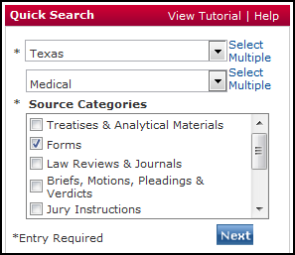

Printing
Lexis provides several options for the researcher to choose from in order to save a viewed document. First, find the Print Toolbar at the top right of the page. It looks like this:

Following is an explanation of the options presented:

The symbol on the far left is a tool to set up your printing preferences to make printing more efficient. Just follow the instructions as provided by Lexis.
The Printer symbol allows you to print the document being viewed.
The Floppy Disc symbol will give you instructions on downloading, or even easier, just click File, and Save As on your browser. Title the document and click OK. The document you are looking at will be saved. Pretty easy!
The Mail symbol allows you to email the document. Very cool, and very easy.
The Phone symbol allows you to actually fax the document right from the computer screen.
The Page Symbol is a very useful printer friendly tool. It allows you to look only at the text of the document without the extra stuff. Give it a try!

Reminder: Everything costs the subscriber (but not the student). So when you are working as a paralegal in a firm, be careful. Just because you email a document to yourself, for example, it does not mean it’s free!

